Media release
1st October 2025
Australian Open serves an ace with Altos Tequila partnership in 2026
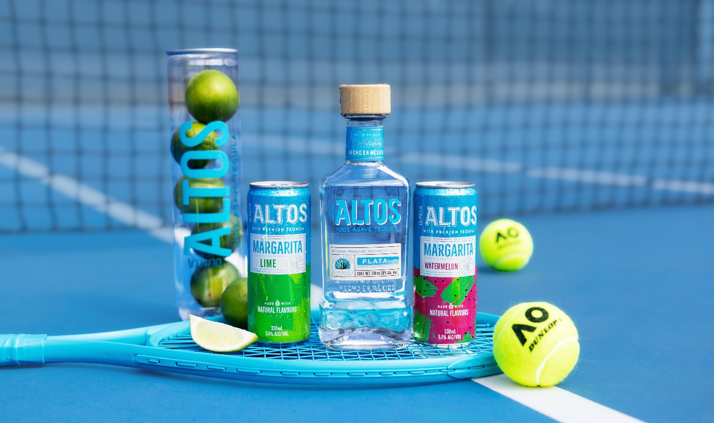
Icons in their respective fields, the Australian Open and Altos are the new doubles pair on the circuit, partnering for the first time to bring a summer of fun to fans at Melbourne's Grand Slam.
As the first Official Tequila of the Australian Open, Altos will be bringing a slice of its home in the highlands of Jalisco, Mexico, to the ever-popular Grand Slam Oval. Over the three-week tournament, the doors of Casa Altos will swing open; a place for summer vibes; top tequila cocktails served at the nine-metre long bar; and a few surprises.
To welcome people to Casa Altos, Co-Creator and recently awarded Best International Brand Ambassador 2025* Dre Masso will fly in to lead the celebration and share the spirit of Altos with guests. Masso created Altos alongside fellow world-renowned industry legend (the late) Henry Besant with esteemed Maestro Tequilero Jesus Hernandez in pursuit of creating a quality tequila for bartenders.
What has followed is a fable similar to that of the best on the ATP Tour; Altos has repeatedly been named the best tequila for margaritas and the best tequila for palomas by Drinks International’s Brand Report 4 years in a row.
Pernod Ricard ANZ Marketing Director Kristy Rutherford said this was a landmark moment for Altos to be joining one of only four Grand Slams globally.
"Altos will be bringing some of the most popular cocktails in the country, alongside a custom AO cocktail," Rutherford said.
"Our home on Grand Slam Oval, Casa Altos, brings to life our individual lifestyle. This is a tequila with true heart, and having Dre Masso here to share it with the thousands set to join us at Casa Altos will bring it to life for spectators even more."
Grand Slam Oval was the place for drinks in 2025, and Altos is the natural fit with tequila being one of the fastest growing spirit categories in Australia.
"We’re delighted to welcome Altos Tequila to the Australian Open family. The AO is all about celebrating tennis, summer and culture, and Altos brings a vibrant energy that fits perfectly with that spirit,” Cedric Cornelis, Tennis Australia Chief Commercial Officer, said.
“From Casa Altos on Grand Slam Oval to courtside cocktails, this partnership is set to elevate the fan experience in a fresh and exciting way."
Altos Lime Margarita and Watermelon premix cans will also be available at bars throughout the tournament, ensuring fans can enjoy premium tequila wherever they are at the AO. Joining Altos is fellow Pernod Ricard brand Código 1530 Tequila, an Official Partner of the Australian Open. Código is an award-winning ultra-premium tequila made from a recipe and process that’s been perfected for generations. Código will be featured exclusively in AO Reserve bars.
Beyond the Australian Open, Altos will join Summer of Tennis celebrations across the nation as the Official Tequila of the United Cup in Perth and Sydney, and the Brisbane, Adelaide and Hobart Internationals.
Ends
For further information, interviews and imagery, contact:
INSERT Project 2045 contact info
About Olmeca Altos:
Olmeca Altos is a super-premium Tequila, made from 100% pure Agave and Tahona liquid, crafted in the heart of Los Altos, 2104 meters above sea level in the western state of Jalisco, in Mexico. Born from a collaboration between Olmeca's own Master Distiller Jesús Hernández and the internationally renowned UK bartenders, the late Henry Besant and Dré Masso, Altos is made in part using the 500-year-old traditional Tahona method, before being distilled in small copper pot stills.

