**PRESS RELEASE**

PERNOD RICARD’S OLMECA TEQUILA EMPOWERS INDIVIDUALITY
WITH FIRST GLOBAL AND ‘MOST FANTASTIC’ LIMITED-EDITION

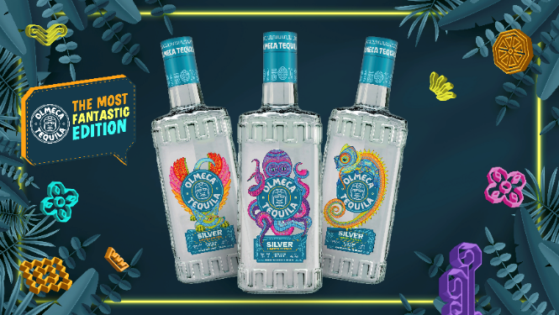

OCTOBER 2024: Pernod Ricard’s Olmeca Tequila is electrifying the tequila category with the release of three striking first and ‘Most Fantastic’ global limited-edition bottles for its award-winning Olmeca Silver. Designed to drive differentiation in a fast-growing – but increasingly crowded – category, these exclusive bottles blend Olmeca´s modern-day party spirit with the rich tapestry of its Mexican heritage.

Created in partnership with Oaxacan workshop "Una Inspiración de Mi Vida", run by acclaimed Tonas y Nahuales artist Victor Fabian – a third-generation artisan from Oaxaca’s Central Valley – the limited-edition artwork for Olmeca Silver spotlights traditional Zapotec craftsmanship through vibrant, quirky interpretations of this revered form of Mexican folk art.

The ‘Most Fantastic Edition’ bottles feature three curious creatures in bright, bold colourways – the charismatic Xolo Dog, the sociable Chameleon, and the multi-tasking Octopus – created to drive standout and command attention on shelves and back bars across the globe. Each figure represents distinct personality traits that reflect the diverse dynamics of partygoers, imbuing the bottles with a profound sense of connection and self-expression.

"Our new limited-edition line-up combines Olmeca’s playful, party spirit with Mexican tradition and has been designed with fun-seeking, Gen Z and millennial consumers in mind,” says Daniela Via, VP Marketing & S&R at House of Tequila – Pernod Ricard. “This audience is increasingly looking to nightlife and bar spaces as outlets for self-expression, and we want to be the brand to help them embrace this. By spotlighting three distinct Tonas y Nahuales to which shoppers can relate, we’re fostering a deeper emotional connection for Olmeca.

“As well as appealing to our core audience, the new limited-edition packaging is also aimed at tapping into the global appeal of Mexican culture. You only have to look at the international prevalence of Mexican cuisine and cocktails to see how popular this trend is. So, launching Olmeca’s first global limited-edition bottles is the perfect way to leverage this further, while catering to the growing demand for high-quality tequila that goes beyond flavour – in this case, by empowering individuality.”

To amplify the launch, Olmeca is rolling out a multi-channel marketing campaign designed to maximise engagement across both on-trade and retail landscapes. ‘The Most Fantastic Edition’ will include a series of on and off-trade activations and events, alongside PR, digital, social media and influencer activity.

On-trade venues can bring the new launch to life with a curated selection of branded materials, such as vibrant shot trays, coasters, and interactive party games. Meanwhile, bartenders around the world will be invited to unleash their creativity by crafting custom Olmeca cocktails, including the ‘Green Perrito,’ ‘Party Diva,’ and ‘Pulpo Splash.’

From mid-November, the limited-edition Olmeca Silver bottles (700ml, 35% ABV) will roll out in various global markets across both the on and off-trade (€22 RRP), including China, Turkey, South Africa, Zambia, Ukraine and Romania. Available at the same price as the original Olmeca Silver, consumers can indulge in this exclusive collection at no extra cost.

-ENDS-
NOTES TO EDITORS

About Olmeca Tequila
Pernod Ricard is committed to promoting responsible drinking and encourages all consumers to enjoy Olmeca tequila responsibly.

At Olmeca tequila we measure every step of the production process to optimise all resources with a special focus on water, energy C02, and waste. Our distillery recycles 99% of all its solid waste, and we are investing in the research of innovative uses for agave bagasse to give it a useful second life.

Established in 1967, Olmeca Tequila is a premium, mix to Tequila which is enjoyed in more than 80 countries including key countries China, Turkey, South Africa and Colombia. Olmeca is the No. 2 premium Tequila outside of the USA and Mexico and its range consists of Olmeca Silver, Olmeca Gold, Olmeca Reposado, Olmeca Añejo and Olmeca Dark Chocolate.

About House of Tequila:
Pernod Ricard-owned House of Tequila is responsible for the brand management of the group’s award-winning ‘Made in Mexico’ range of tequila and mezcal, comprising Olmeca, Altos, Avión and Del Maguey. Its portfolio of Mexican spirits showcases the full spectrum of high-quality tequila production, and a laser focus on excellence and quality is the driving force behind the House’s work.

Using the finest ingredients, blended by experts, and with generations of experience and tradition behind its conception, the House of Tequila portfolio can be found in over 100 markets across the globe, including Mexico, USA, Australia, UK and more.

For further information, please visit https://www.houseoftequila.mx/about-us/

About Pernod Ricard
Pernod Ricard is a worldwide leader in the spirits and wine industry, blending traditional craftsmanship, state-of-the-art brand-building, and global distribution technologies. Our prestigious portfolio of premium to luxury brands includes Absolut vodka, Ricard pastis, Ballantine’s, Chivas Regal, Royal Salute, and The Glenlivet Scotch whiskies, Jameson Irish whiskey, Martell cognac, Havana Club rum, Beefeater gin, Malibu liqueur and Mumm and Perrier-Jouët champagnes.

Our mission is to ensure the long-term development of our brands with full respect for people and the environment, while empowering our employees around the world to be ambassadors of our purposeful, inclusive, and responsible culture of authentic conviviality. Pernod Ricard’s consolidated sales amounted to €11,598million in fiscal year FY24.

Pernod Ricard is listed on Euronext (Ticker: RI; ISIN Code:FR0000120693) and is part of the CAC 40 and Eurostoxx 50 indices.

For further information or images, contact:
Laura Martin/Jasmine Burnett
Richmond & Towers Communications
Tel: +44 (0)20 7388 7421
E-mail: laura@rtc.london/jasmine@rtc.london

IWSC 2024 (Silver Medal), International Spirits Challenge 2024 (Bronze Medal),

